**Analysing Housing Prices In Metropolitan Areas Of India**

**1 INTRODUCTION**

* 1. **Overview**

House price prediction in a metropolitan city in India is a valuable solution for potential home buyers, real estate agents, and investors. By leveraging historical sales data, property details, and location-specific information, a predictive model can accurately estimate house prices. The model's scalability, real-time updates, user-friendly interface, and transparency ensure it meets the needs of stakeholders. Integration capability, data privacy, and cost-effectiveness are also important considerations. By addressing these requirements, the prediction model provides reliable insights, empowering stakeholders to make informed decisions in the fast-paced real estate market.

1.2 **Purpose**

The **Census Commission** of India defines Metropolitan cities as those Indian cities having a population of **more than 4 million.**

The 74th Amendment to the Indian Constitution defines a metropolitan area as An area having a **population of 10 Lakh or 1 Million**or more, comprised in one or more districts and consisting of two or more Municipalities or Panchayats or other contiguous areas, specified by the Governor by public notification to be a Metropolitan area.

**2 Problem Definition & Design Thinking**

Problem Understanding, also known as Problem Definition or Problem Identification, is the initial and critical phase of any data analysis or problem-solving process. It involves gaining a clear and comprehensive understanding of the problem at hand, its context, scope, and objectives.

**2.1 Empathy Map**

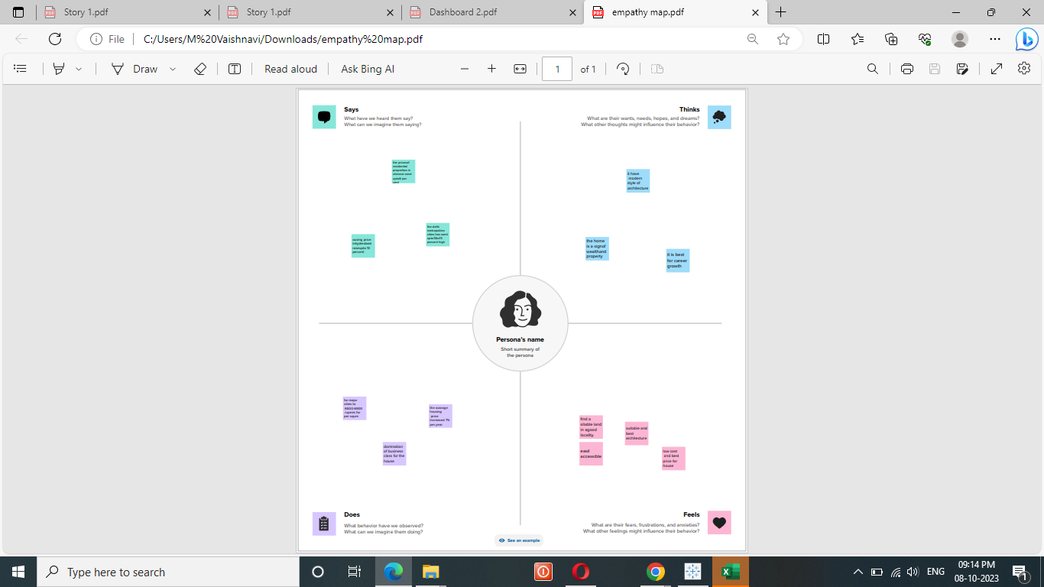

**2.2 Ideation & Brainstorming Map**



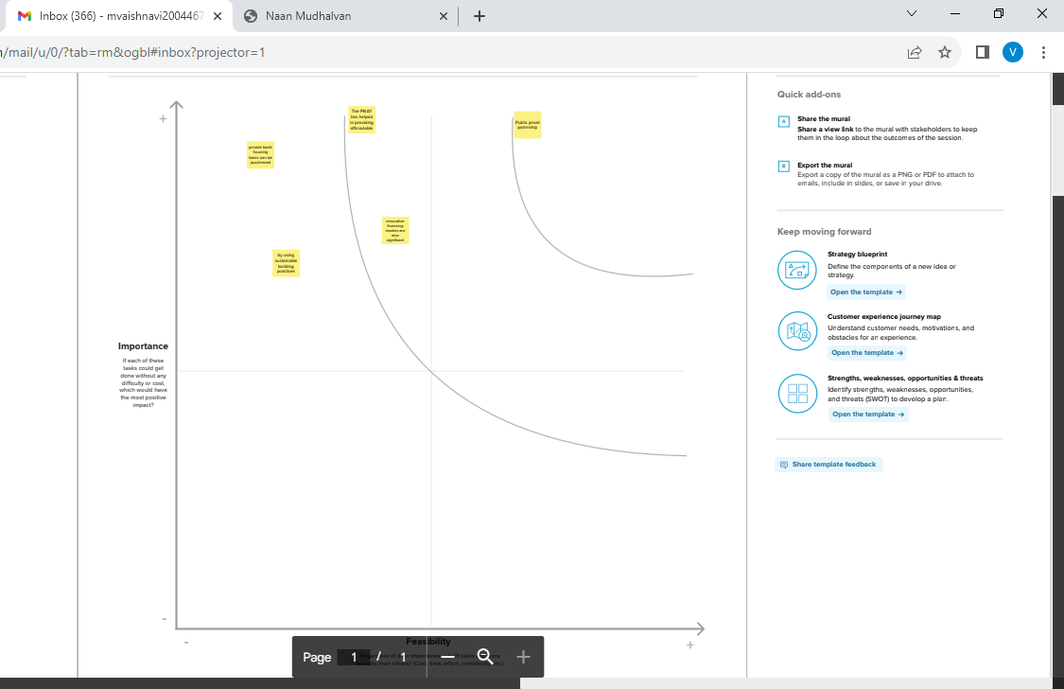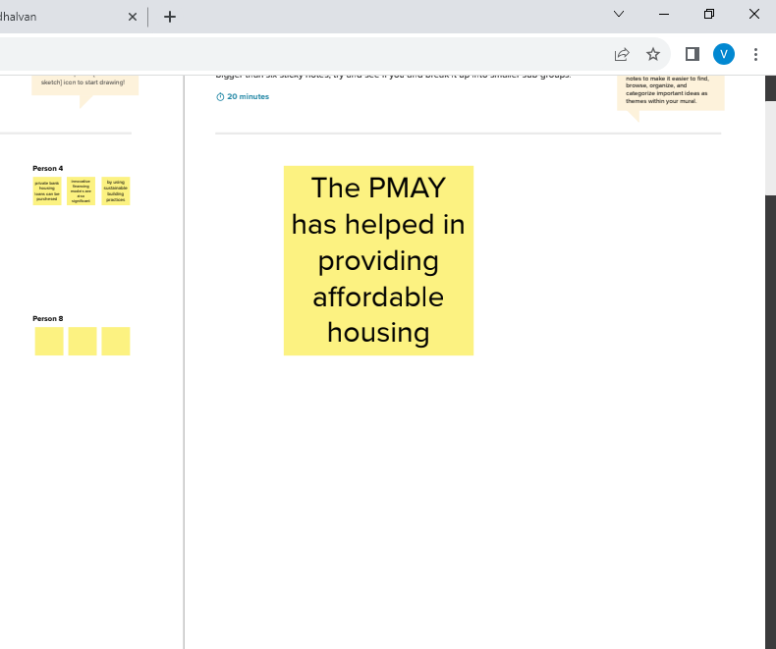

1. **RESULT**

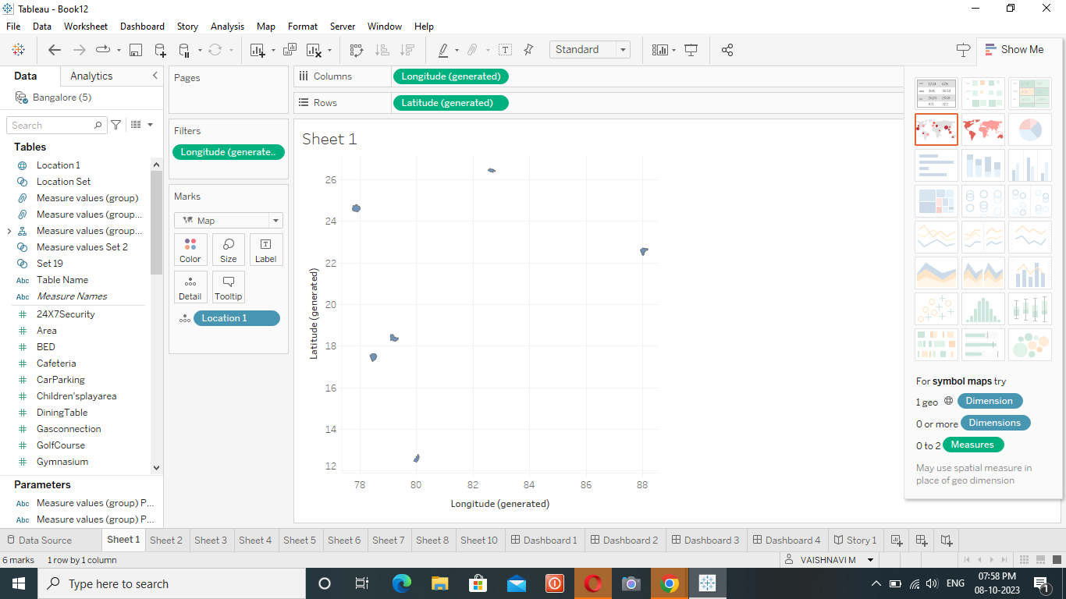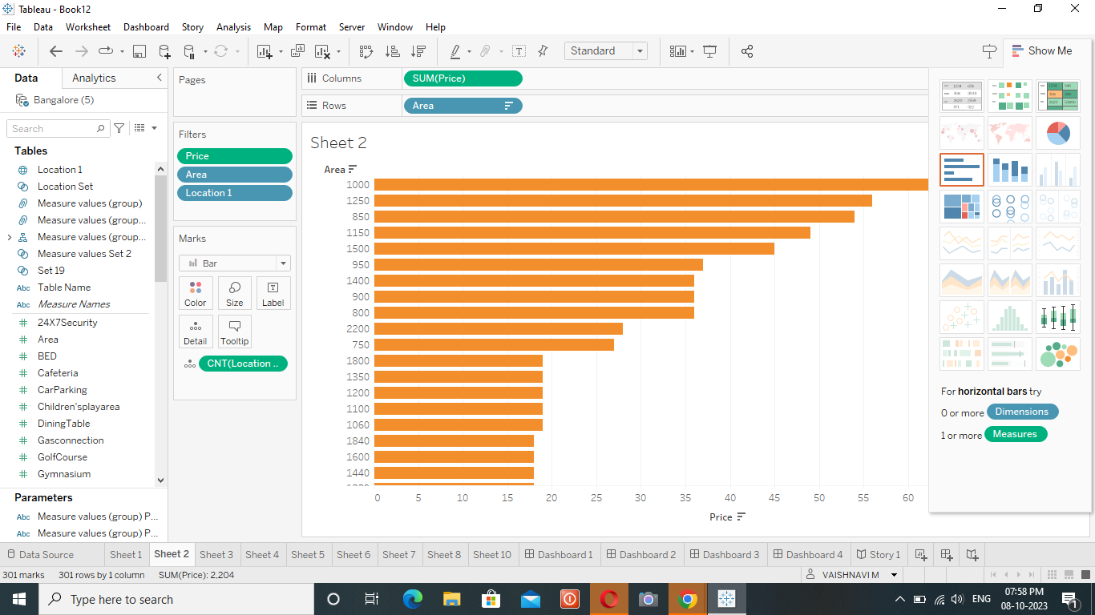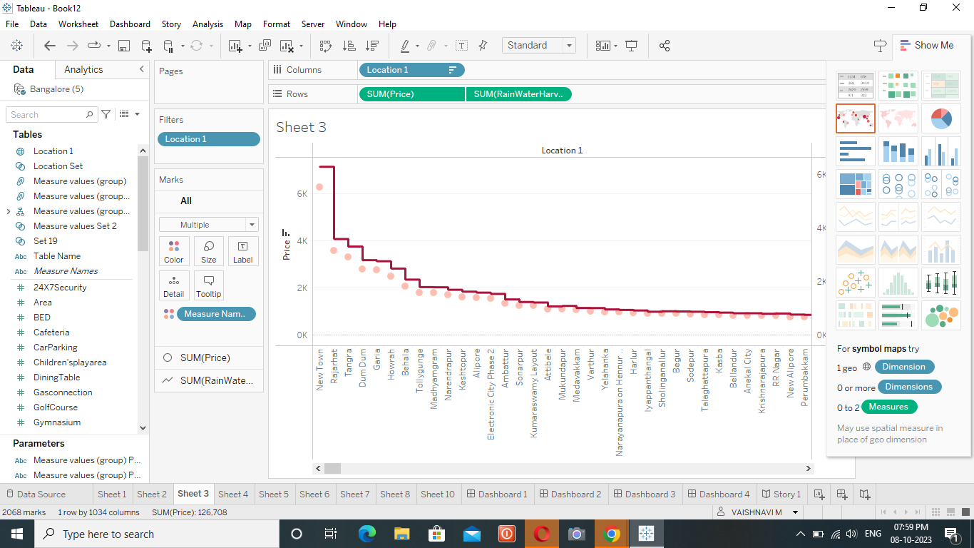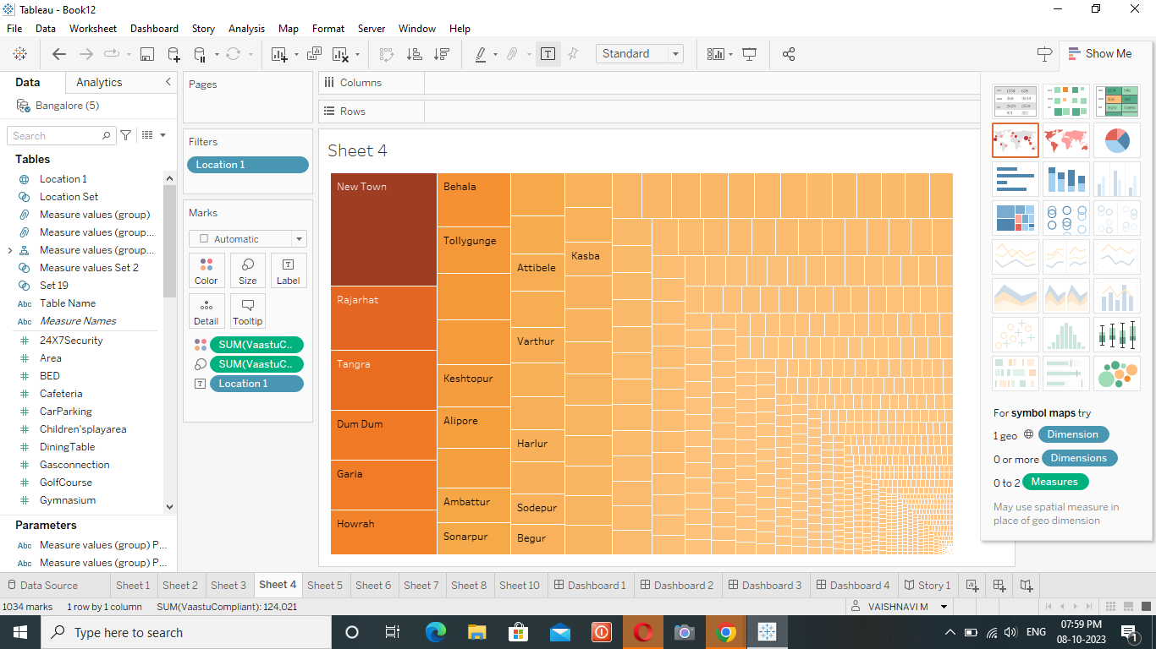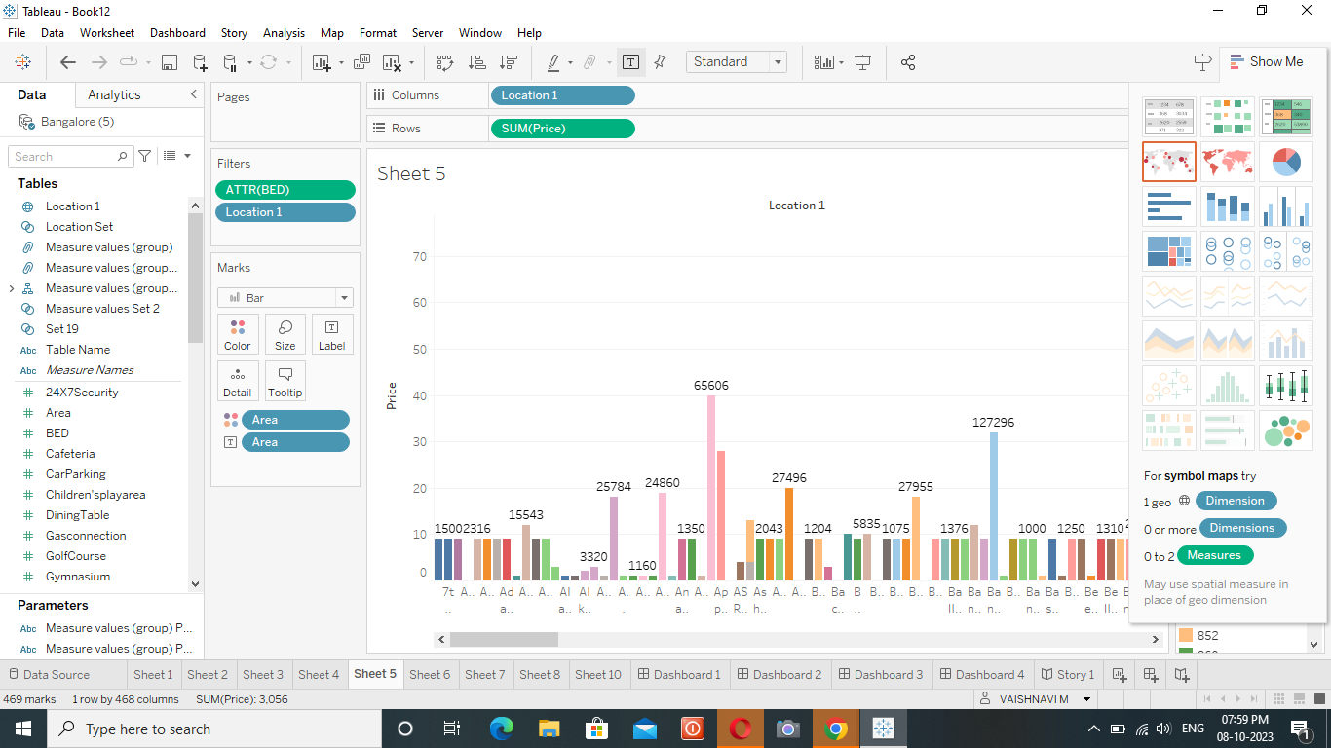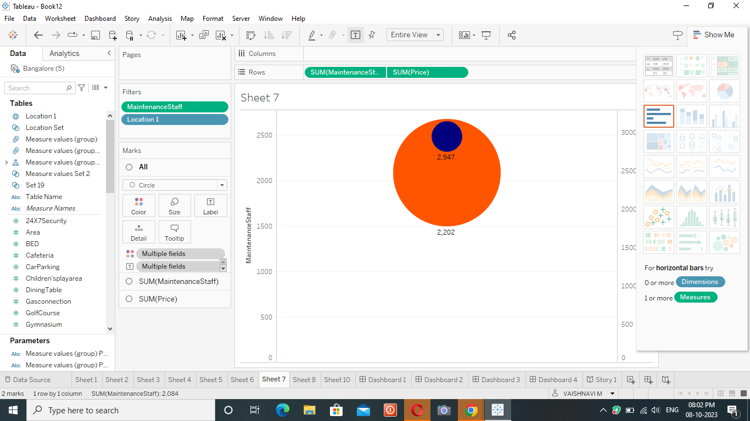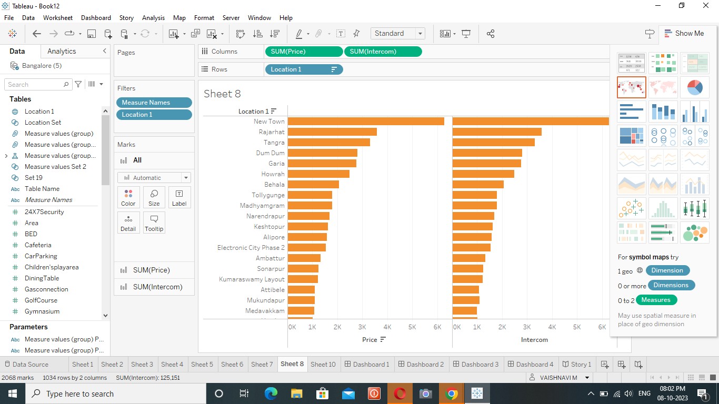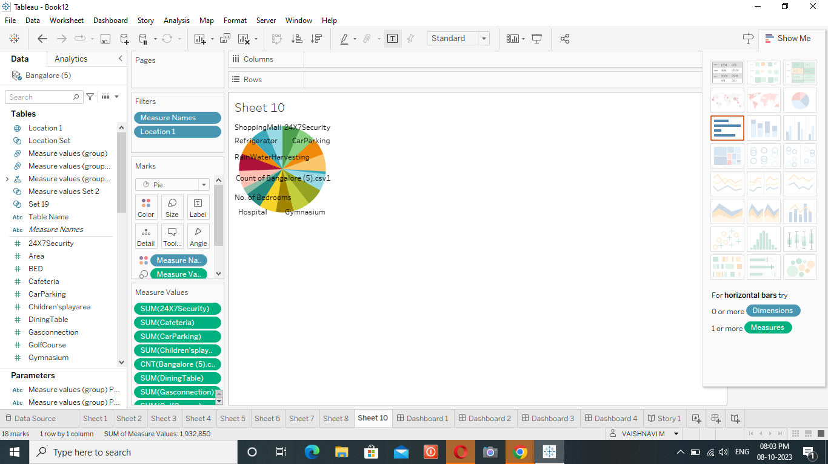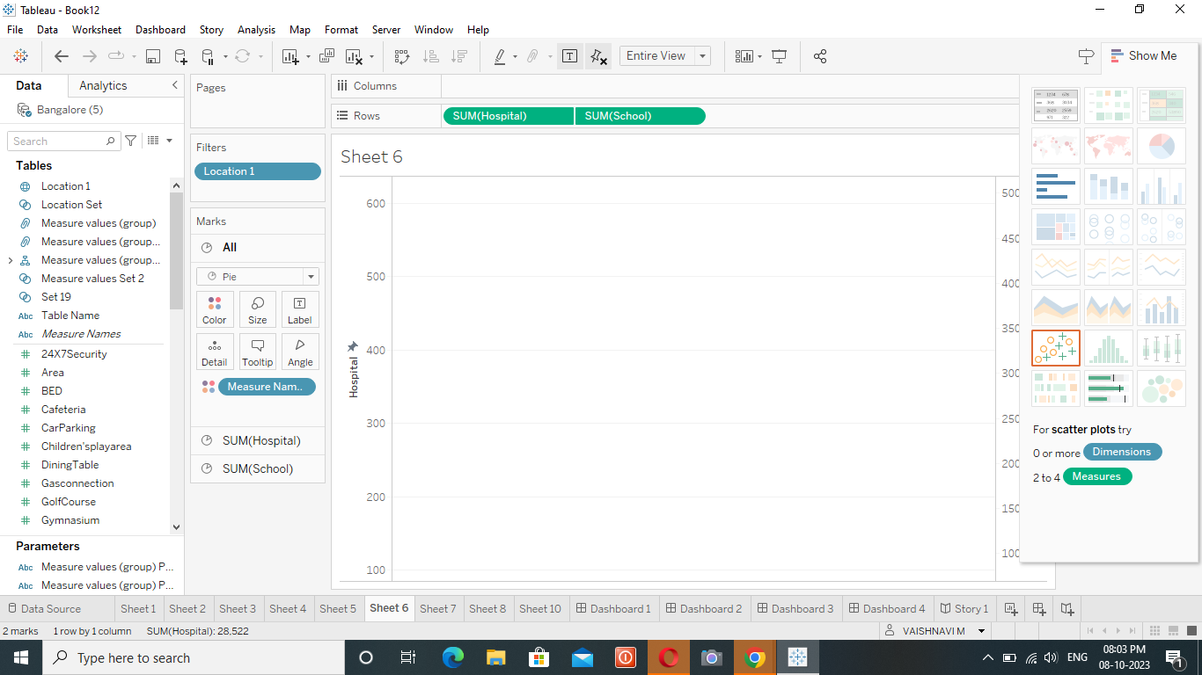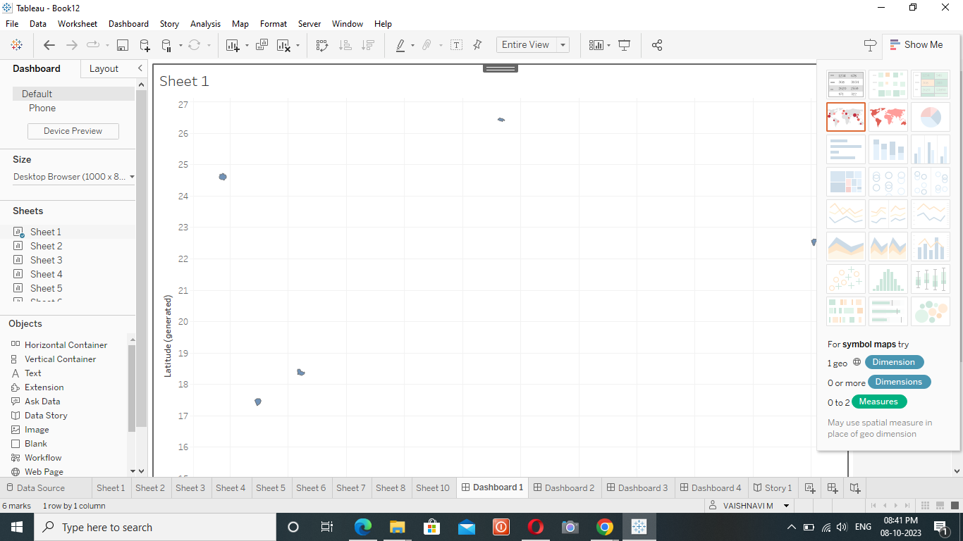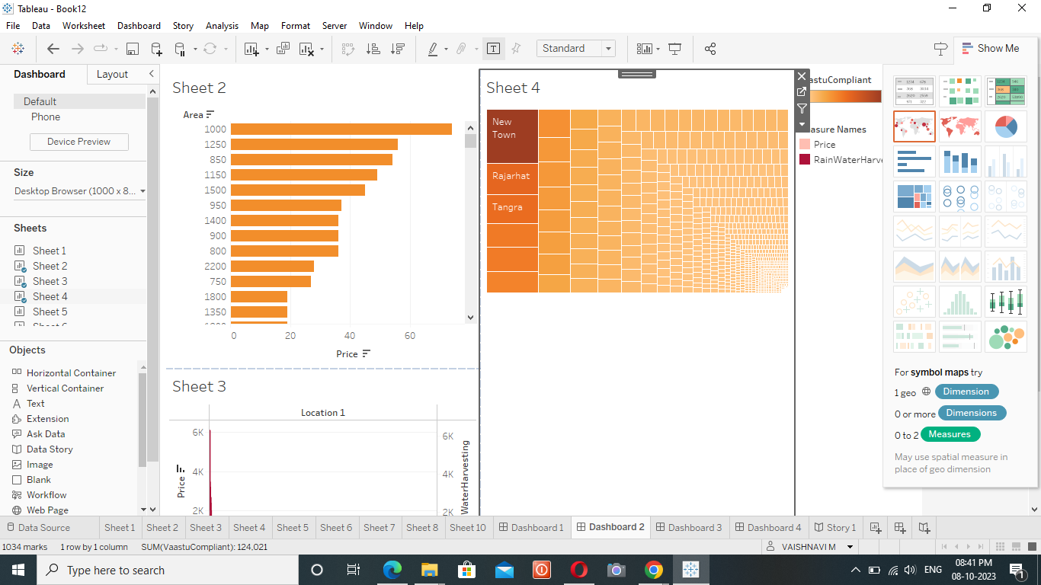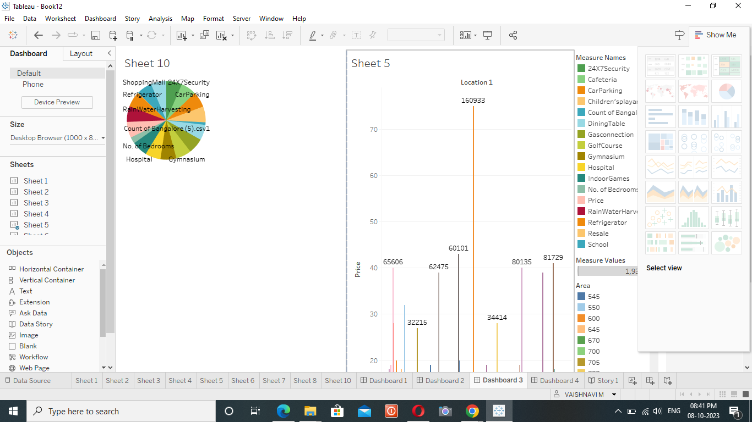

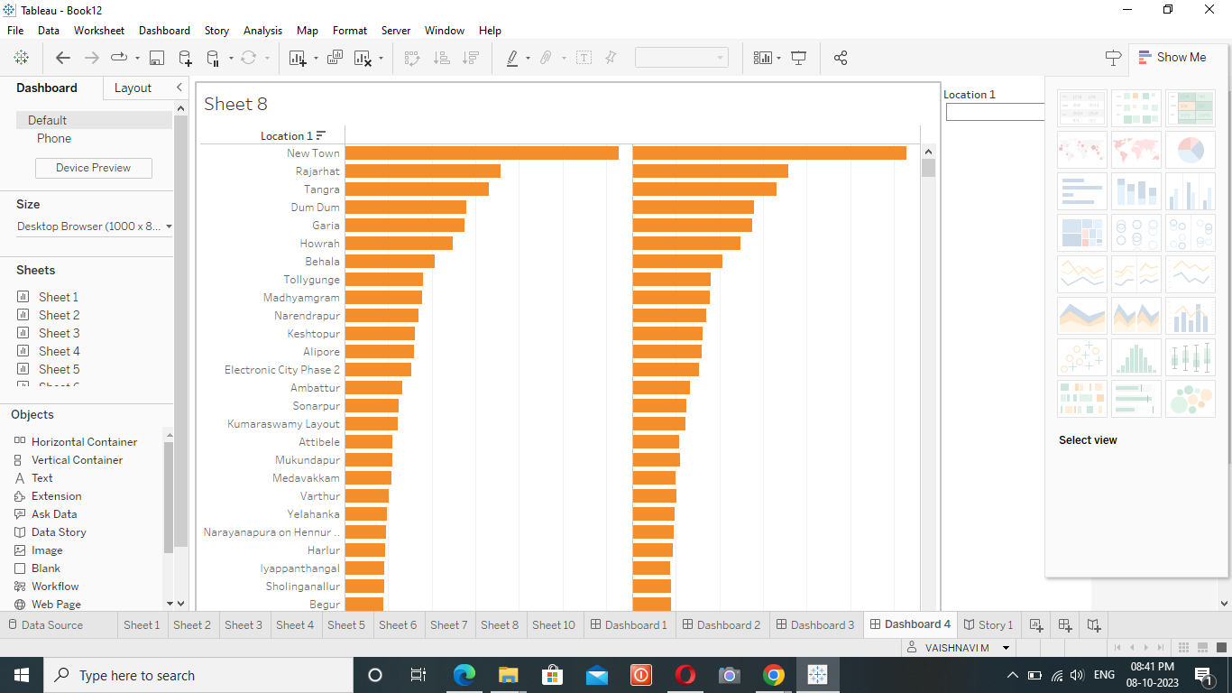

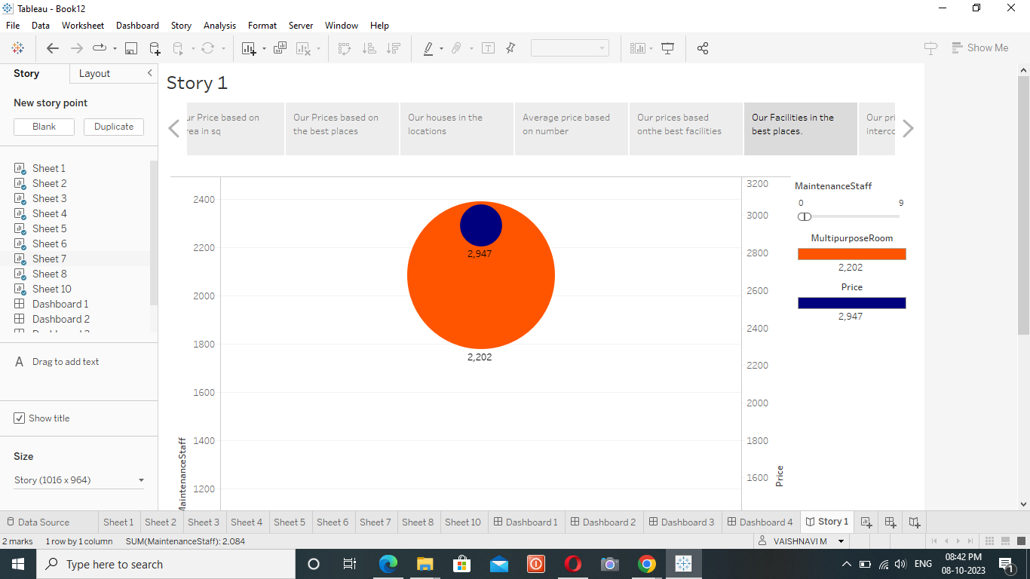

1. **ADVANTAGES & DISADVANTAGES**

**4.2 Advantages**

* There are many advantages and disadvantages to living in a big city.
* The advantages include access to better schools, more job opportunities, and more entertainment options.
* The disadvantages include higher cost of living, more crime, and greater pollution levels.
* Ultimately, the decision of whether to live in a big city depends on your own personal preferences and needs. The decision of whether to live in a big city is a personal one.

**4.2 Disadvantages**

* It’s expensive. The cost of living is high in most big cities, which can make it difficult to make ends meet if you don’t have a high-paying job.
* The pace of life is fast. If you like a slow-paced lifestyle, you might find that the constant hustle and bustle of a big city wears you.

1. **APPLICATION**

House price prediction can help the developer determine the selling price of a house and can help the customer to arrange the right time to purchase a house. There are three factors that influence the price of a house which include physical conditions, concept and location.

1. **CONCLUSION**

Based on the criterion of price convergence, house prices in the 15 metropolitan cities do not converge to the LOOP. This implies that the housing markets in the different areas operate as segmented independent local markets.

**7 FUTURE SCOPE**

Remarkably, even with the influx of new properties, prices in primary economic hotspots are skyrocketing. The ISB – Housing.com Housing Price Index (HPI) shows an increase of 7.21% in property prices during Q2 2023, a jump from both Q1 2023's 6.78% and Q2 2022's 2.83%.